You’re keeping the baby. Now what?
For this assignment, you will be answering 6 questions in the form of a virtual blog. They are divided into 2 sections. The first is after you decide to keep the baby. The second is for after baby is born. Before creating the blog, you will be planning your answers and looking up any information you don’t know about yet.
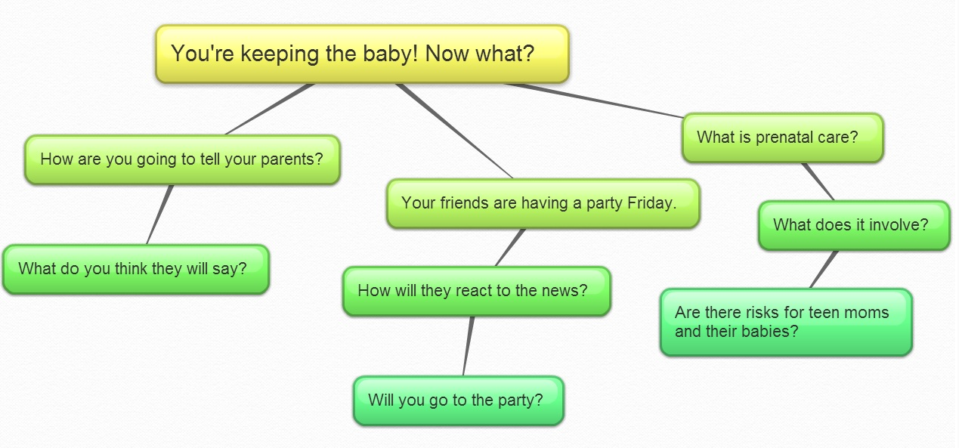
Part 1

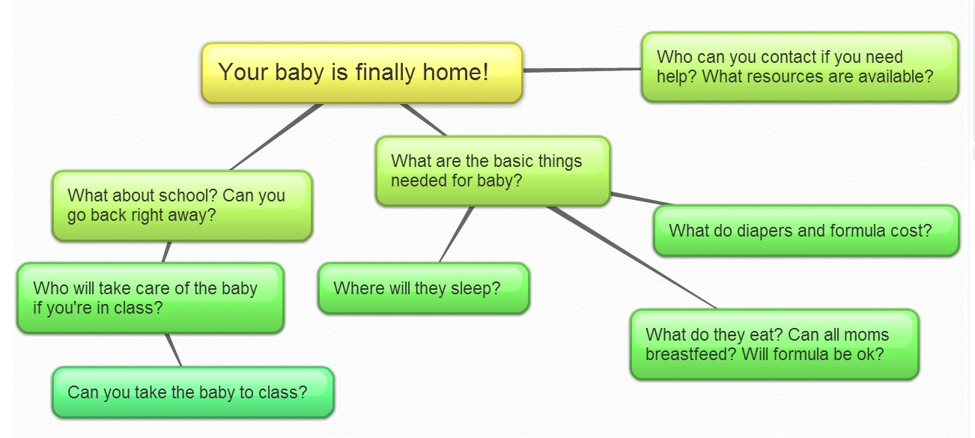
Part 2

Once you have your answers ready, plan out which app(s) or programs you plan to use for creating your blog. Ensure you have each of the following done to consider your assignment completed:
☐All 6 questions answered from one point of view (either teen mother or teen father)
☐Sources for your found information
☐Assignment sent to me or uploaded with link sent to me

